In the online library, go to the Library Search box and
Left click the click here link at the bottom of the box
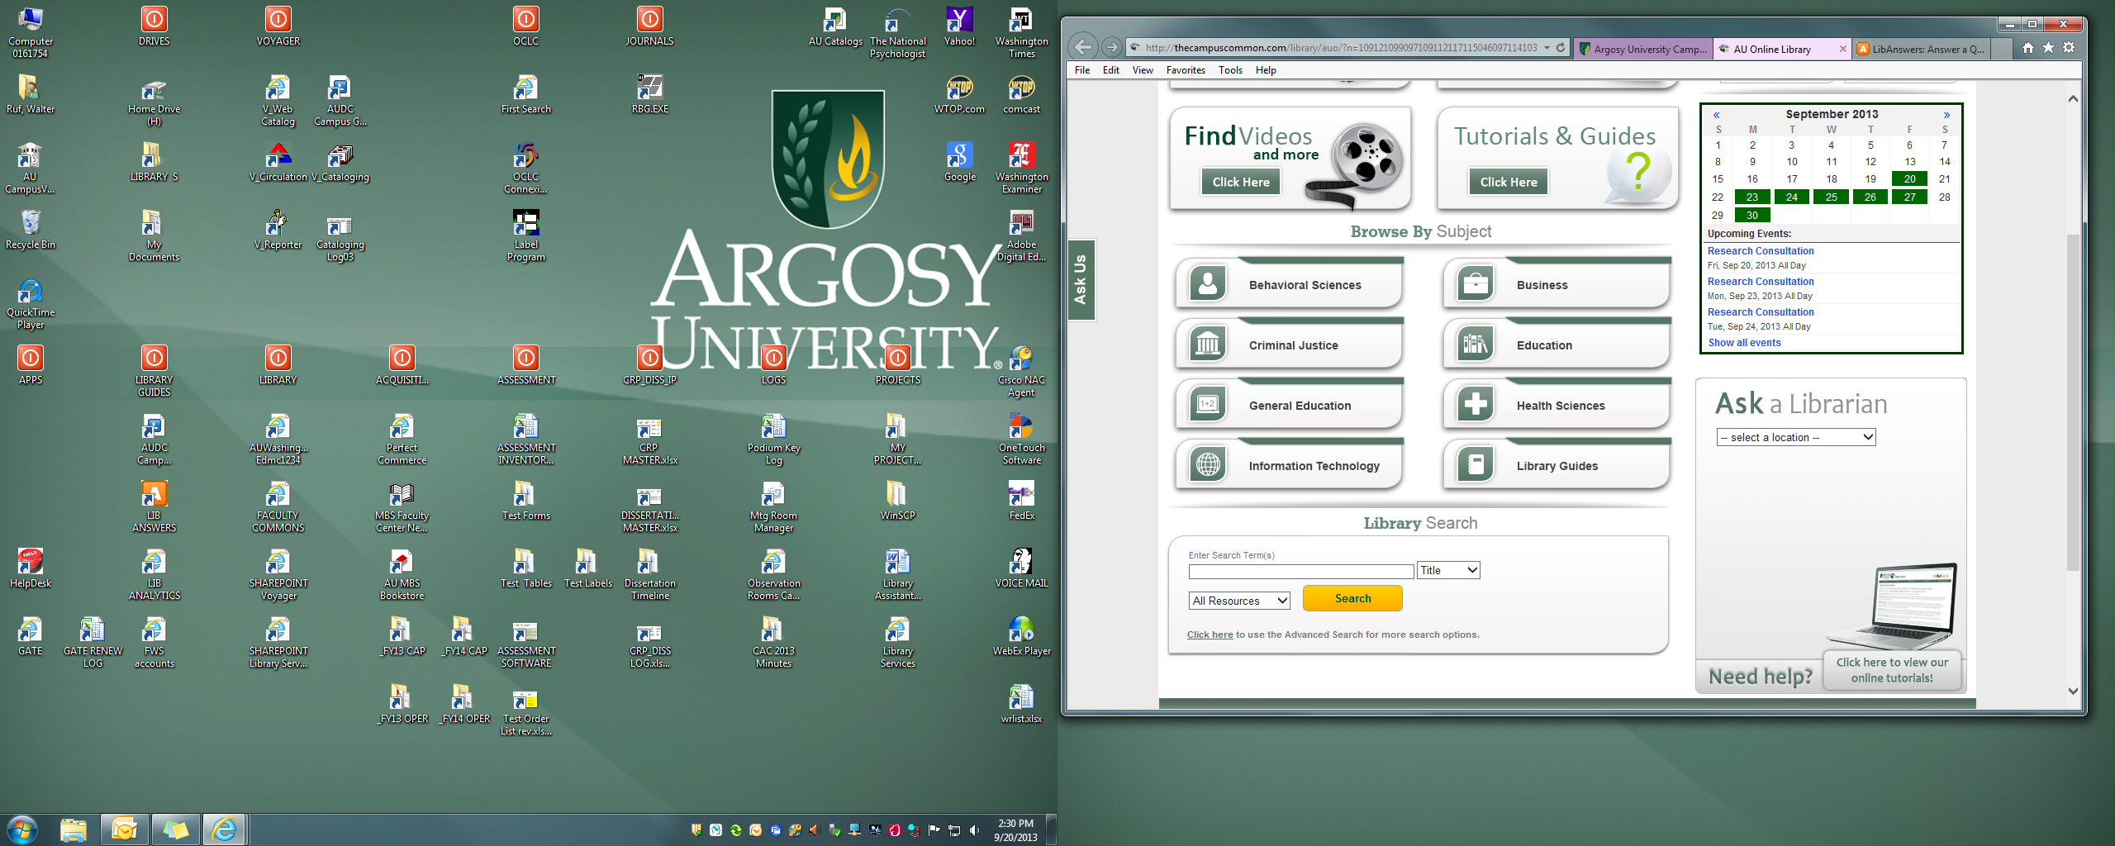
Enter your search terms in the boxes, use quotes for phrases such as
“defense infrastructure” or “north america”
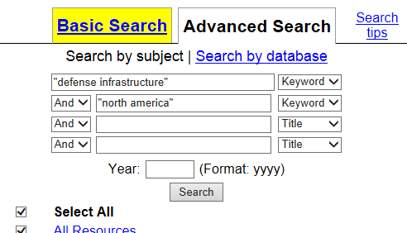
You can further limit your results by selecting “peer-reviewed” or one of the Topics listed in the side bar
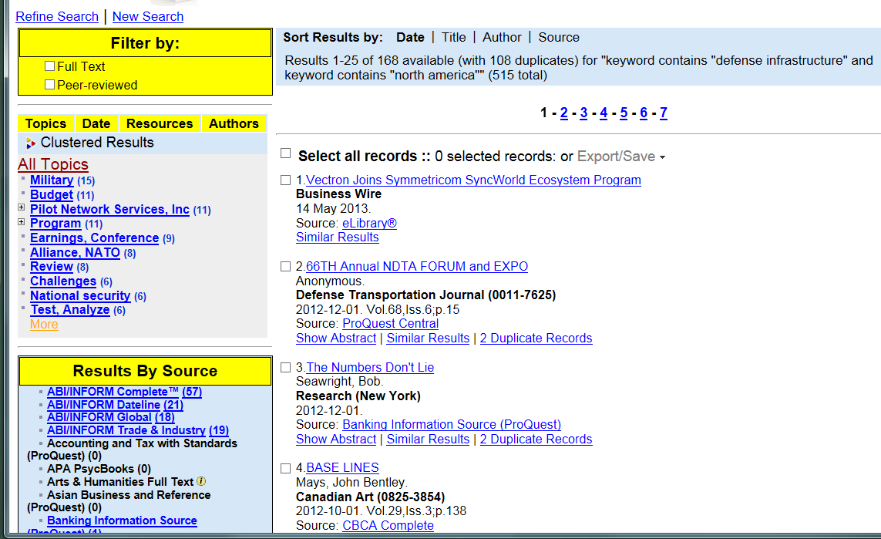
If you are not finding sufficient relevant articles, another method utilizing Google search is to type keywords
into the Google search box and adding pdf to the end. For example,
North America Defense Infrastructure pdf
Adding the pdf seems to locate articles rather than broader company or other links.

