Accessing Articles with Citation
For Students
Online Library Home Page
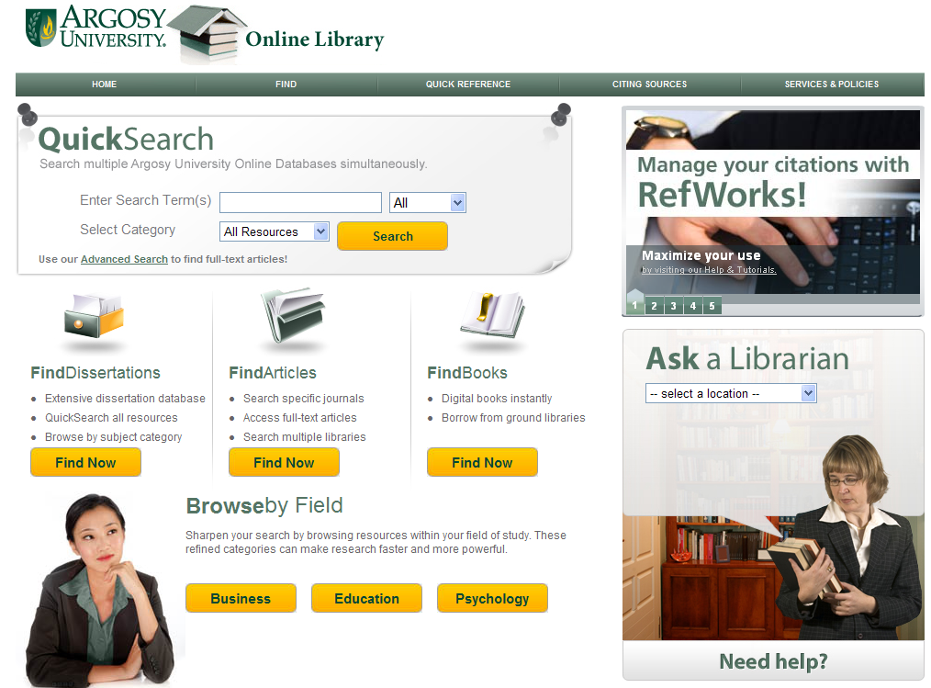
Click here
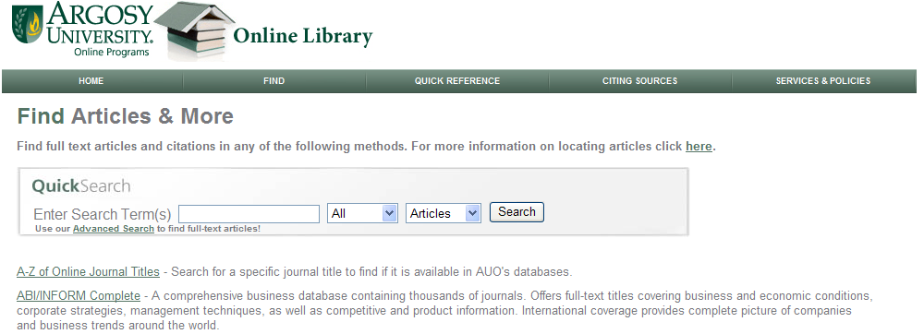
Click here

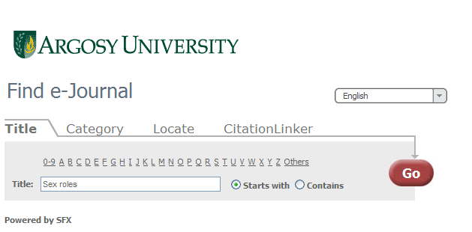
Type in the name of the journal here
Then click on “Go”
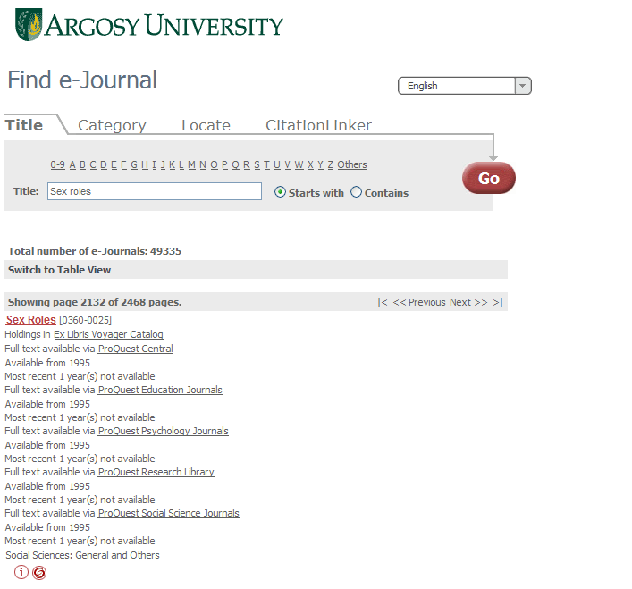
Click on appropriate link (that is the link containing the year of the journal you are seeking). It’s your choice of link if they all have the same coverage.
Choose one

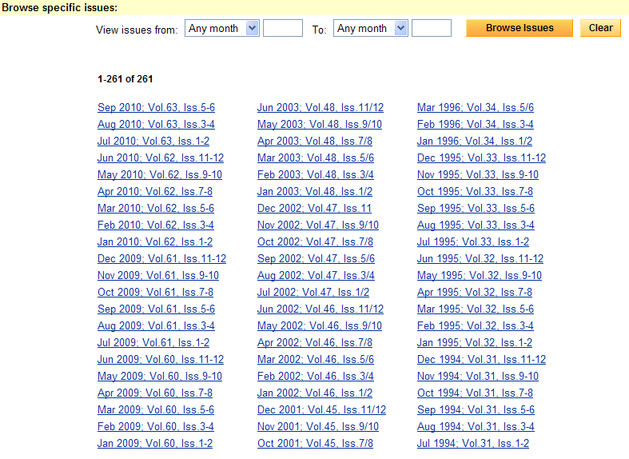
Link to the issue you need to access

Please note this screen may look different depending on the database you access.

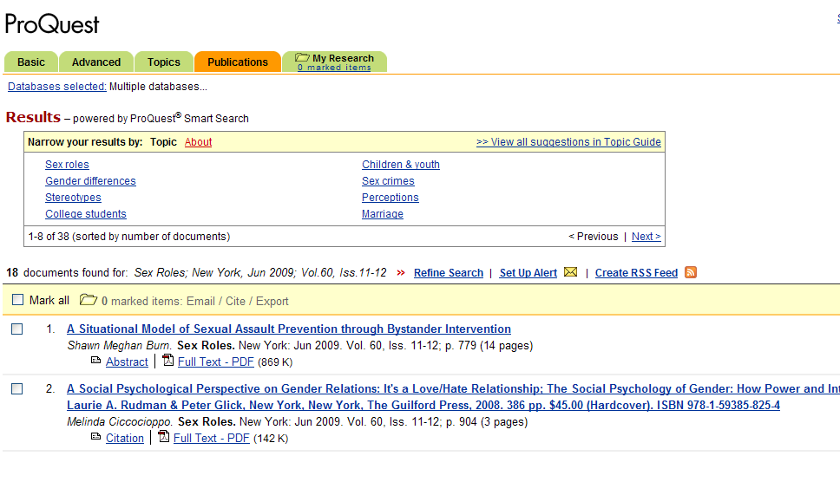
Access the full-text of the article here
Please note this screen may look different depending on the database you access.

